
Task 1 – designs
Nathan Share


Set Task Brief
This brief will be written out for exclusively my own reference purposes, and not to be used as any content of my own at submission time.

You work for a software development company. The company has secured a new contract to develop a digital solution for Greenfield Local Hub (GLH). GLH is a cooperative of local farmers and food producers. GLH offers:
- A single location retail outlet for locally produced food and drink
- Collective marketing for local farmers and food producers
- Product management, stock control and product traceability.

GLH (the client) would like to develop a digital solution that will:
- Provide information about the producers, their methods, and the benefits of buying locally
- Allow customers to:
  - View products with transparent pricing and availability
  - Place orders for collection or delivery
  - Manage their accounts and view order history
- Provide a dashboard to enable producers to manage stock levels, update product details and view orders.

The client has conducted market research with existing customers to identify features that could be included in the digital solution. The features suggested by the clients are:
- Order management, scheduling and tracking features
- A loyalty scheme that provides discounts and special offers
- Accessibility features to support a wide range of users

Research

The Local Harvest
The Local Harvest (Site) is a UK-wide delivery service of local goods of various types. It offers a wide range of local produce that can be ordered from places local and national, allowing you to see where your food is coming from, directly from the source.
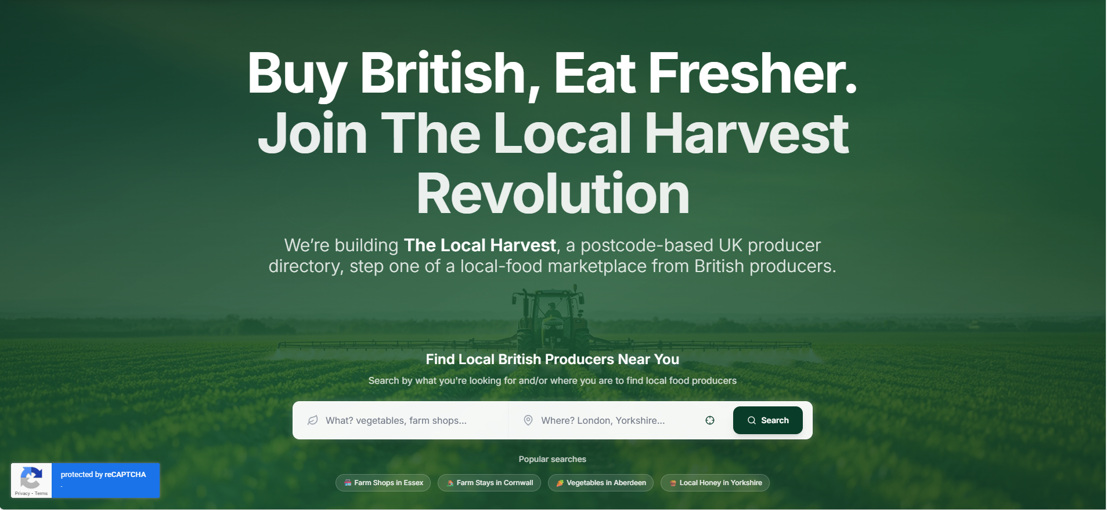
To open, the site contains 2 key things. A large catchphrase, to catch the users’ eye, and an input bar in which the user can select what they’re looking for and where. It is also worth noting that they include popular searches to help give the user a sense of direction on the site right from the get-go.
The choice of the green hue over the image in the background also immediately puts the user in mind of nature and natural products, further fitting the brand image when paired with the image of the farming process chosen.
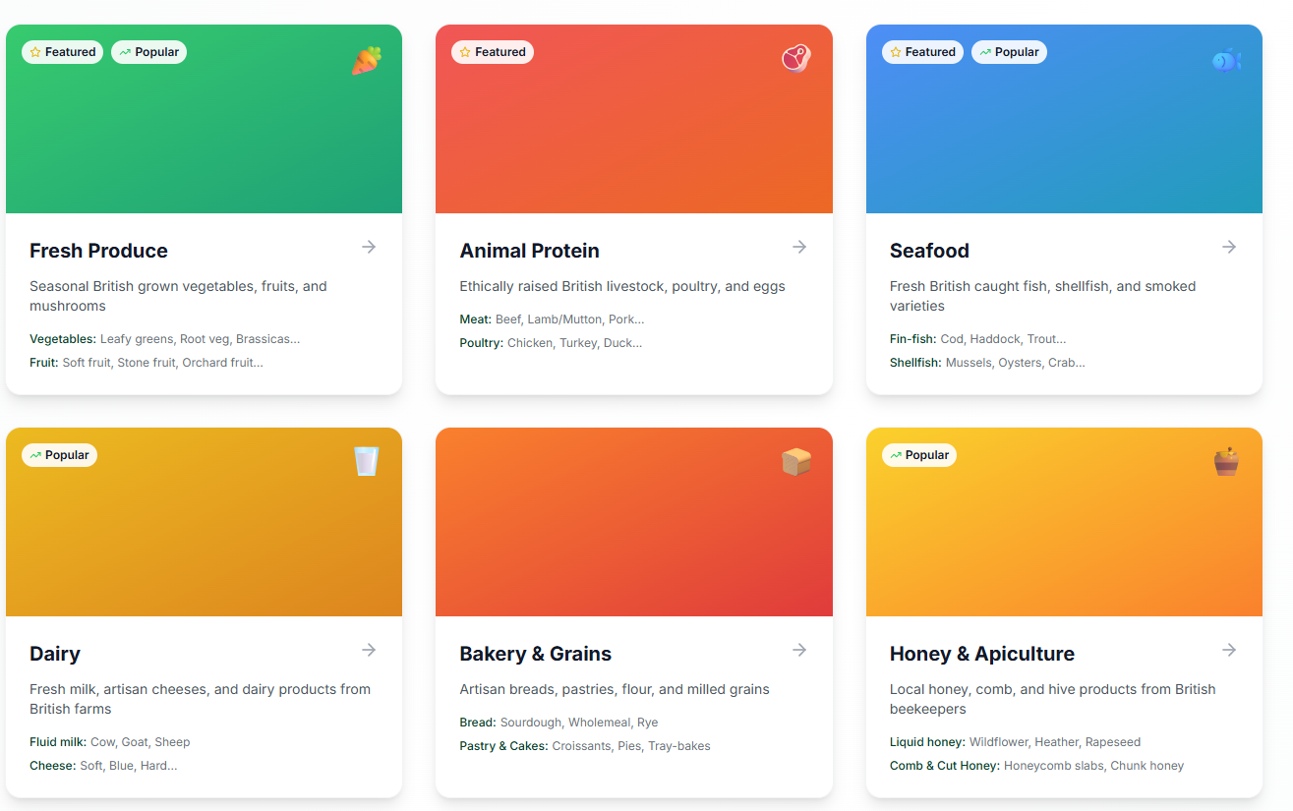
Another thing I see as worthy of note is this category searching menu. This offers a clear way for the user to choose what they would like to search for, and it offers simple and clean tags such as “Featured” or “Popular,” guiding the user to the site’s more known or popular products.
This menu also offers a small description of what kind of products to expect in each section, meaning a user can see things they may be interested in without sifting individually through each page.

Big Barn
Big barn (Site) is a similar site, offering local food produce across the UK depending on your location.
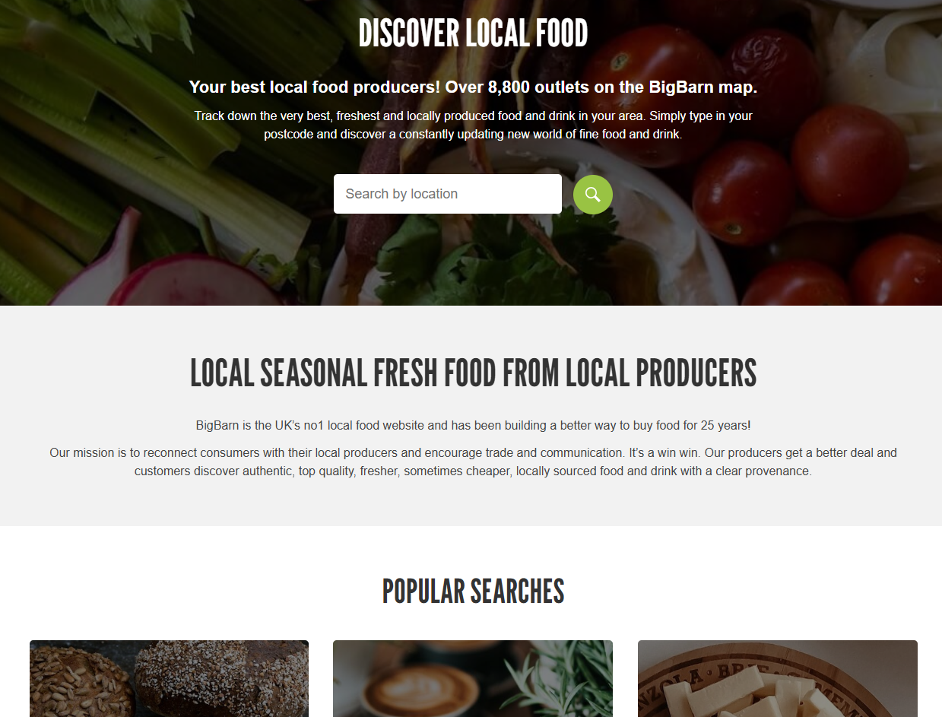
Very similarly to The Local Harvest, the Big Barn offers a hook line on the opening page in large letters – “Discover Local Food,” which immediately leaves no room for deliberation in what the site aims to do for the user. It also opens with a search bar offering the user to search for local produce by their location via a postcode. They also offer a popular search list, again offering a sense of direction to a browsing user.
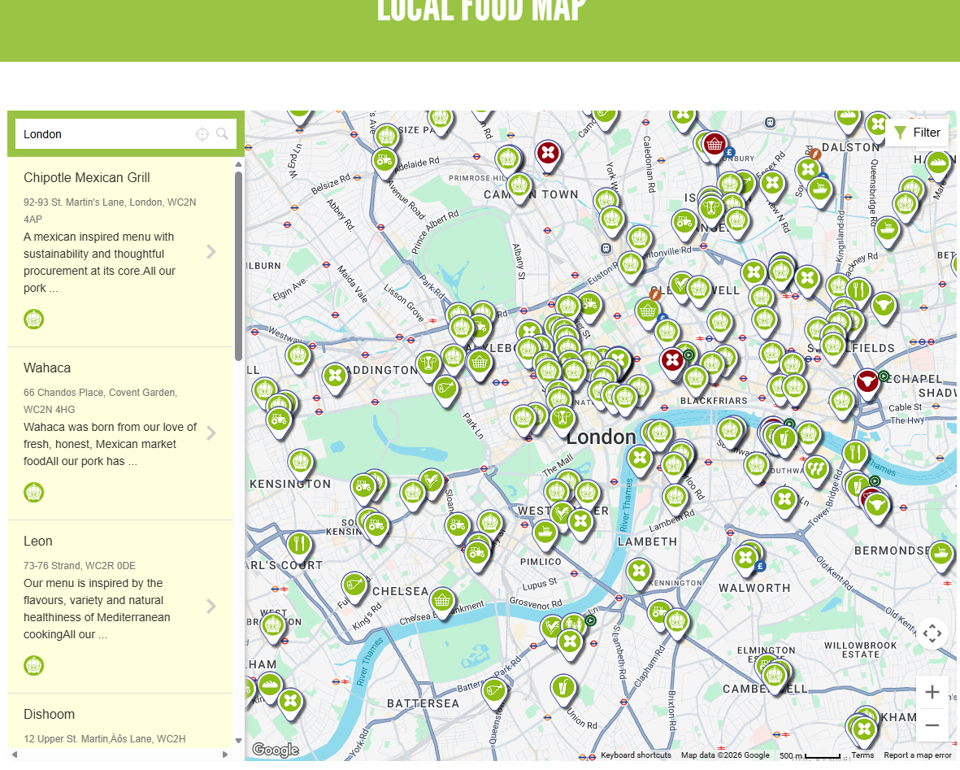Something I especially like about this site is its immediate access to a local food map, which offers itself a double-purpose. While you can order local produce from the site, it also offers itself as a way to show the user where to go should they want to buy their own food.
As you can see from the pins above, each type of shop or restaurant is visually different from one another, which offers a key to the user to see what is offered where, even at a glance. If not through a map, a way to show local food vendors would be an efficient extra feature to be added to further meet requirements.

Business Context

Provide information about the producers, their methods and the benefits of buying locally.
The client has asked me to make a solution that provides information about the producers and their methods, along with the benefits for the user of buying locally. Offering this will inform the users of the benefits of local produce and potentially the harmful side to overprocessing of food and working conditions for local farmers. Doing so may allow users to become educated on this topic and informing others. This allows word to spread and increases the amount of people who would be likely to purchase locally. This offers higher traffic to the business resulting in more revenue for both the business and its shareholders.

View products with transparent pricing and availability
Offering the capability to view products and their prices with things like taxation and delivery costs factored in removes the need for users to calculate actual costs themselves and allows the website to feel more catered to the users themselves. Offering a level of transparency to the price will help reduce the feeling that buying locally is expensive or “daunting,” allowing more users to consider buying their produce locally and through the site, again resulting in an increased revenue flow. This also solves the problem that many people believe that ordering from local sources is more expensive or difficult in some way, by breaking down that barrier and allowing the user to connect simply with local producers.

Place orders for collection or delivery
Allowing the user to order for either collection or delivery gives the user the choice on whether to collect the food themselves or (possibly at a slight increase in price) have it delivered to their door. Giving the user this level of freedom and offering a delivery system for direct-from-the-source produce is relatively untapped in the market for an affordable price, and with full customisation of the order. This would mean that the client’s solution has a unique feature to stand on, which would mean people would exclusively use GLH’s digital solution over any others’, boosting traffic and revenue massively.

Manage their accounts and view order history
Giving a user the ability to manage their account details and viewing order history is an incredibly important feature for the site as it allows for the user to find locations they liked and potentially order again or show others. This ability to cross-reference their past orders could tie-in with a button that allows them to re-order the same product again, which could offer an improved User Experience with a feature similar to that of Just Eat. This quality of life may compel a user to remain loyal to the site and therefore increase overall lasting revenue per user, including increasing the average speed at which a user places an order, both of which boosting revenue for the shareholders.

Provide a dashboard to enable producers to manage stock levels, update product details and view orders.
Producers also need to be able to use this site and offering a dashboard for the producer to change stats such as price and stock levels ties in with giving the customer a transparent price of the product and its details. This also allows producers to add information on themselves, further adding credence to the first function, in which the user must be able to view information on the producers themselves. This also solves the problem of producers finding it difficult to manage all their stock levels on a website, as it gives a simple and intuitive interface that offers a clear, 1-2 click way to update stock levels on any product they have put up for sale.

Order management, scheduling and tracking features
For a site like this, order management is imperative. The ability for the user to see what they have ordered is without question one of the most important things this site must be able to do in order to be a part of the market. This will allow users to cancel or change their orders providing that it is early enough in the process, and to see a time/location estimate on where the product currently is in its journey from grocer to customer. This solves the issue that ordering food locally or straight from the source can be difficult as delivery options are usually limited due to the smaller budget of the seller compared to that of supermarkets or large companies.

A loyalty scheme that provides discounts and special offers
Offering a loyalty scheme ties in similarly to the prior mentioned feature about seeing past orders. Offering certain bonuses (such as free delivers every few orders) for a loyal customer incentivises them to stay around and order more in the future. This increases the rate at which users will order and the likelihood of a recurring user, where other sites may lack this drive. This offers upped revenue and better overall customer incentive schemes, boosting inflow and shareholder value.

Accessibility features to support a wide range of users.
Accessibility features are nigh mandatory for compliance with Legal and Regulatory guidelines such as the WCAG and other similar forms of legalities. This is not to say these accessibility features cannot be expanded upon beyond the bare minimum, however. Offering things such as font size changing and colourblind schemes are the main things highlighted in the legal guidelines but offering a comprehensive Text-To-Speech system and light/dark mode options would further expand upon those for users who are hard of sight.

Project Aim

The aim of the project is to provide the client with a comprehensive digital solution to meet any current needs they have, as well as futureproofing their functionality for upcoming times. These goals will be achieved by producing a solution that will:
- Provide customers with information about local producers, including their methods and what kinds of products they offer
- Place an order from one or several local producers to be compiled and delivered either to the customer’s address, or for collection by the customer at a defined location.
- Manage their account details and view past orders
- Reorder past orders again, stock permitting
- Allow the user to wish list products
- Provide a dashboard for producers to manage stock levels or update product details/set up sales on their products.
- Order management, scheduling and tracking
- Offer a loyalty scheme that provides benefits to the users
- Offer accessibility settings for the users that are hard of hearing/sight.
- Offer the customer a way to view which retailers are local and their stores.
Each of these points will be expanded upon in upcoming sections.

Functional Requirements

User Profiles
Steve – Local farmer who would like to put his products up for sale to a wider audience. Older male who suffers with poor sight without his reading glasses and isn’t the best with computers.
Jeanne – Long-Term local produce buyer with 2 children who is trying to find a new way to purchase local produce after her schedule recently became full with childcare.
Alicia – New buyer of local goods who is unsure of why she should choose local farmers over larger institutions but is willing to try, and also suffers with minor Tritanopia colour-blindness.

Functional Requirements Table
Requirement | User Story | User Acceptance Criteria | Justification
Provide customers with information about local producers, including their methods and what kinds of products they offer | As Alicia, I would like to know a producer’s methods so that I better know why I should order from them.  As Jeanne, I would like to know information about a local producer so I know what kind of products they specialise in. | User can access home page  User can choose to view a grocer  Site displays details on the chosen grocer and their products  Solution must comply with WCAG (Web Content Accessibility Guidelines)  User must be able to search for a producer by name  Solution must filter to match user’s search query | Providing the customer with info about local producers helps them to know who to purchase from and why, allowing them to make an informed decision on what’s best for their money.
Place an order from one or several local producers to be compiled and delivered either to the customer’s address, or for collection by the customer at a defined location | As Jeanne, I would like to place an order from several locations that I can have delivered to my home so that I don’t have to travel to get them myself.  As Alicia, I would like to place an order for collection so that I can drive to a local designated drop-off area so that I can drive to get my products without having to pay delivery cost. | User must be able to log in to their account  User must be able to navigate to viewing products  User must be able to select a product and quantity  User must be able to add product to basket  User must be able to select drop-off or delivery  Solution must factor in delivery costs if that is user’s selection  User must be able to choose a local designated drop-off spot if that is their choice  User must be able to input a postcode for delivery if that is their choice.  Solution must validate inputs of postcodes  Order must be linked to customer and go through into order menu.  Solution must comply with WCAG (Web Content Accessibility Guidelines) | Allowing the user to place an order for either pickup or delivery offers options to the customer, allowing them to get their products the way they want to, with regards to their availability and wants or needs.
Manage their account details and view past orders | As Steve, I would like to manage my account details so that I can change my password to keep my account safe from hackers.  As Alicia, I would like to change my details so that I can change my address and postcode, should I move house.  As Jeanne, I would like to view my past orders so I can quickly reorder the same products as before without having to hunt down the producers’ stores again. | User must be able to log in to their account after registry  User must be able to navigate to their account menu  User must be able to choose which details to edit.  User must be able to change the selected detail  Solution must reflect updated detail in the database  User account must reflect updated details.  User must be able to navigate to “past orders” tab  Solution must keep track of a user’s past orders.  Solution must comply with WCAG (Web Content Accessibility Guidelines) | Offering the ability to manage account details is needed in case the user feels that they need to edit their password or linked e-mail address should it need to change for any reason. This also complies with legalities to do with a user’s right to change and edit their data at will.
Reorder past orders again, stock permitting | As Jeanne, I would like to reorder past orders so that I can order quickly and not have to divert my attention from my busy schedule for too long. | User must be able to log in to their account after registry  User must be able to navigate to their account page  User must be able to navigate to “past orders” tab  User must be able to click “Order Again” button.  Cart must automatically refill with the same products and take user to order screen.  User must be able to input details and order for pickup or delivery. | Offering the user the capability to reorder allows for them to efficiently order what they like, should they not feel the need to change it.
Allow the user to wish list products | As Alicia, I would like to wish-list products so that I can keep an eye on new products I would like to try when they go on sale or lower in price. | User must be able to log in to their account  User must be able to view products  User must be able to wish-list a chosen product  User must be able to navigate to wish-list button  Solution must reflect that user’s wish-list of products. | Allowing the user to wish-list products allows them to keep an eye on the things they like, offering a more efficient user experience than manually searching up the same products to find out if their details have changed.
Provide a dashboard for producers to manage stock levels or update product details/set up sales on their products. | As Steve, I would like to view a dashboard for my products so that I can change the price or stock level of my products within one or two clicks/drop-down menus | Staff user must be able to log in  Staff must have a different layout of site  Staff user must be able to navigate to “My Store” page  Staff must be able to select a product from their store  Staff must be able to edit product info  Staff must be able to increase/decrease price or stock  Solution must comply with WCAG (Web Content Accessibility Guidelines) | Offering a dashboard for staff users gives them the ability to update product details in a clean way, improving UX for Staff and resulting to a minimised chance of error with pricing or order details.
Order management, scheduling and tracking | As Alicia, I would like to track the location of my orders and get an estimated time of arrival so that I know when to set out and pick them up from the drop-off spot.  As Jeanne, I would like to change my order details in case I mistakenly order the wrong thing and would like to change it before shipping.  As Steve, I would like to track orders I have sent out so that I can see where my products are and that they have made it to the customer well. | User must be able to log into their account  User must be able to navigate to “Orders” tab  Solution must reflect user’s current orders  Solution must display status of order according to staff  Staff must be able to update order status  User must be able to edit details if order has not yet been packaged  User must be able to cancel order if order has not yet been packaged  Solution must comply with WCAG (Web Content Accessibility Guidelines) | Allowing for the customer and staff to edit the status or details of an order at certain points allows for all parties to stay informed on what is expected and what can or can’t be changed. This offers extra communication between customer and grocer, allowing a better User experience for both.
Offer a loyalty scheme that provides benefits to the users | As Jeanne, I would like a loyalty points scheme so that I can gain benefits for staying loyal to the site for extended periods of time. | User must be able to log into their account  User must be able to navigate to rewards page  User must be able to see their rewards points  User must be able to redeem rewards points for certain bonuses (vouchers, free delivery, etc.)  Users must gain rewards points every time an order is successfully shipped to them  Rewards points must be gained at a rate of 1 per 10p of total order cost  Solution must comply with WCAG (Web Content Accessibility Guidelines) | Offering a loyalty scheme incentivises users to stay and continue to choose this solution over potential competitors, whilst upping the likelihood that a customer will order again.
Offer accessibility settings for the users that are hard of hearing/sight. | As Steve, I would like accessibility settings so that I can use the site even without my glasses to help me see.  As Alicia, I would like accessibility settings to offer a colourblind setting for my Tritanopia | User must be able to navigate to settings page  User must be able to change accessibility settings  If user is logged in, settings must save to the user’s account.  User must be able to toggle between light/dark mode or system default.  Solution must comply with WCAG (Web Content Accessibility Guidelines) | Offering accessibility widens the potential market of customers and grocers who would be able to access the site and its contents without difficulty. This Improves user experience and allows for a greater general access capability for all kinds of user. This also complies with legal standards globally.
Offer the customer a way to view which retailers are local and their stores. | As Jeanne, I would like to know which retailers are closest to me so that I can order from places that will make it to me faster and fresher.  As Alicia, I would like to know where is local to me so that I know where I can drive to, in order to pick up my orders. | User must be able to input a chosen town/city from a dropdown menu  Solution must search database for retailers local to chosen city/town  Solution must display local retailers  Solution must comply with WCAG (Web Content Accessibility Guidelines) | Allowing the customer to view where local retailers are keeps the industry standard practice of other businesses in the market and allows the user to see that there is local producers near to them who could offer goods close enough for fast and fresh delivery.

